**Ecommerce Store Webapp**

**PTStore**

|  |  |
| --- | --- |
| **Authors** | **C1808G2 - Group ..** |
| * NGUYEN PHUONG MINH THONG – Student1144404 (Leader) * NGO HOANG PHUC– Student1136445 * NGUYEN HONG SON--Student1144387 |
| **Centre Name** | Aprotrain Aptech |
| **Date** | 7th , January 2021 |
| **Semester** | 4 |
| **Instructor** | PHAN HUU TRI |

**HCM City, 7th January 2021**

* This is Home page:

The menu bar can help you access other sites like Specials Offer , Contact

At the end of the page there are some information about us shown on the footer bar ,and both of them are the main parts which appears on all of other pages.

**\*\*\*\*\*\*\*\*\*\*\*\*\*\*\*\*\*\*\*\*\*\*\*\*\*\*\*\*\*\***

* This is a slideshow showing images of newly posted products on sale, which is displayed on the main page to ensure that customers won't miss them
* This is an image showing the most special products of the shop such as new products on the market, best-selling ...

if you want to **buy products** on the website, you need to **log in or register to buy the product**. At the right of the menu bar there is a registration and login button

* After a successful login. you can add the products you want to buy to your shopping cart ( you can find the vendor's product name or username by filling out the keyword here )
* And here's your shopping cart when you've chosen the right products
* Press the Next button to earn your cart return
* Complete the invoice information for us to deliver to you. and press the Purchase button

This is your order. **we will order by email to you** !!!

* **Vendor:**
* If you want to be the seller of products in our website. please register in advance. click ON BUSINESS WITH PTSTORE in the left corner of the site
* Register and Login

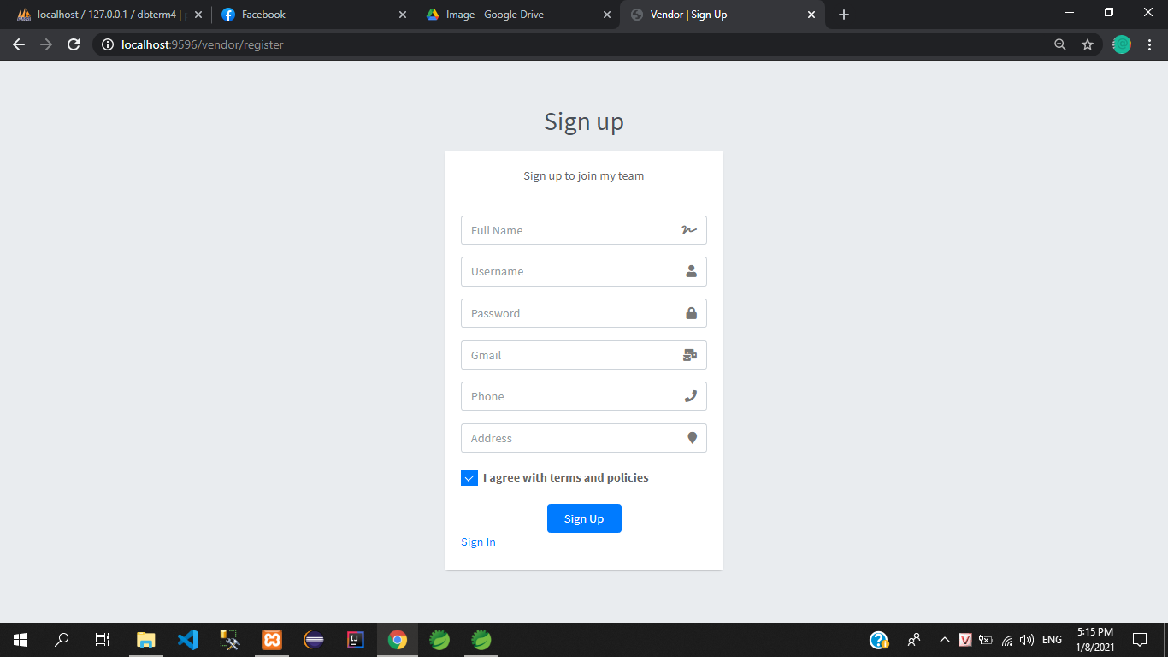

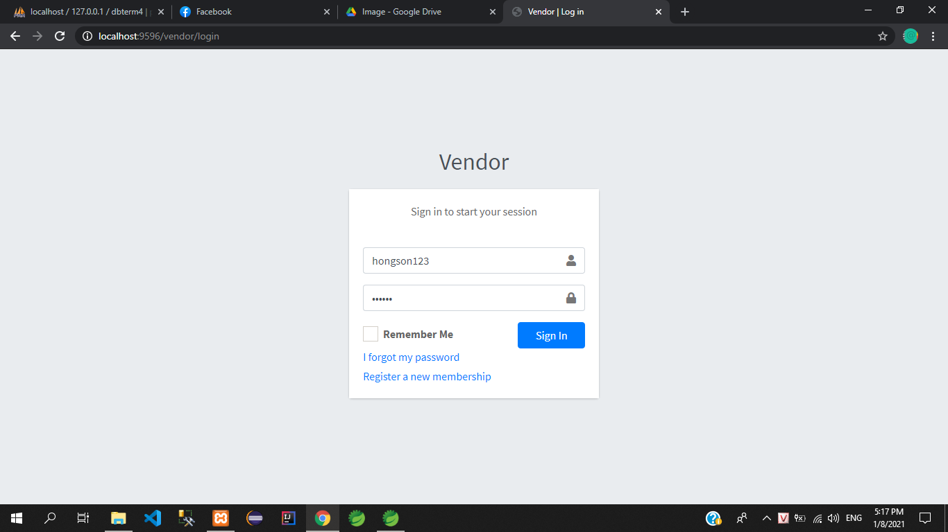

* First, when we sign in successfully, we will have this interface welcome. Vendor can view its statistics

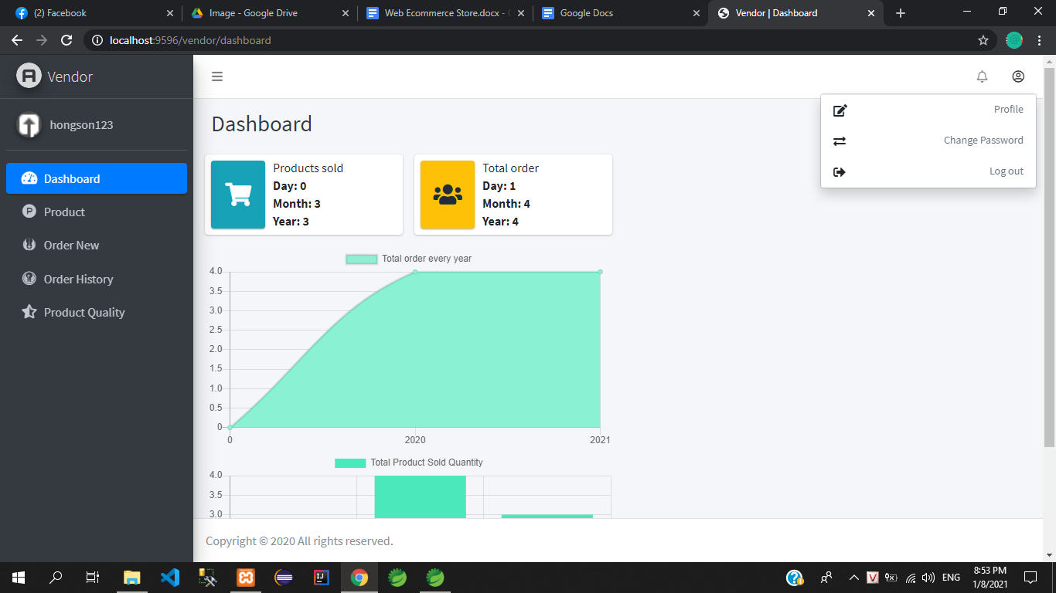

* Vendor manages its products (click on the View/Edit button to see details)

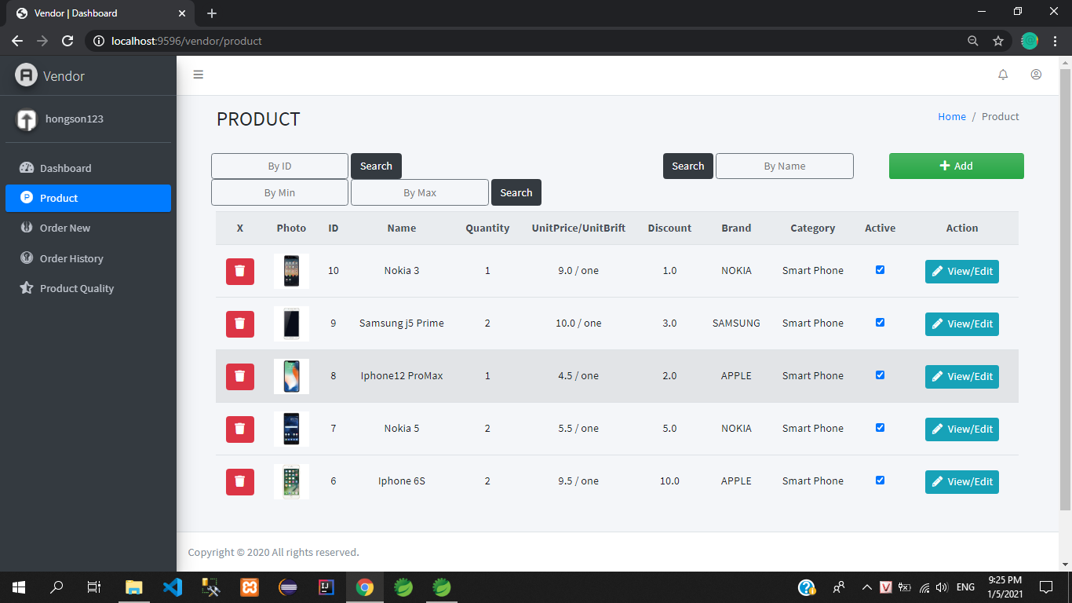

* This is the detail page of the product you can edit some things related to the product

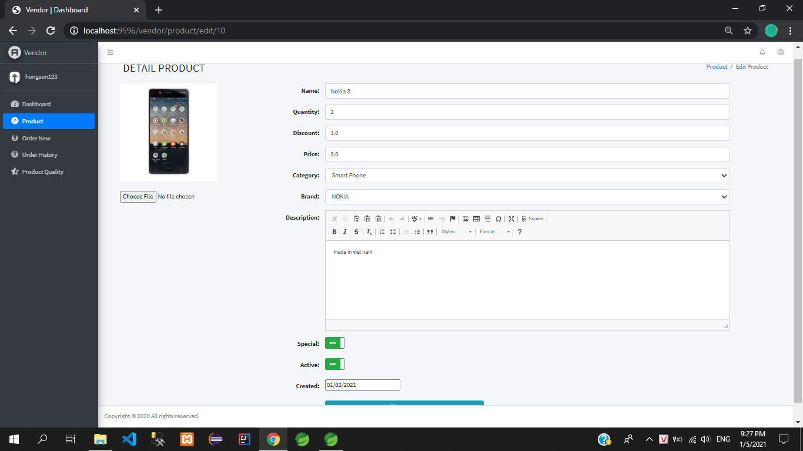

* On Product and press the Add Product button to add new products

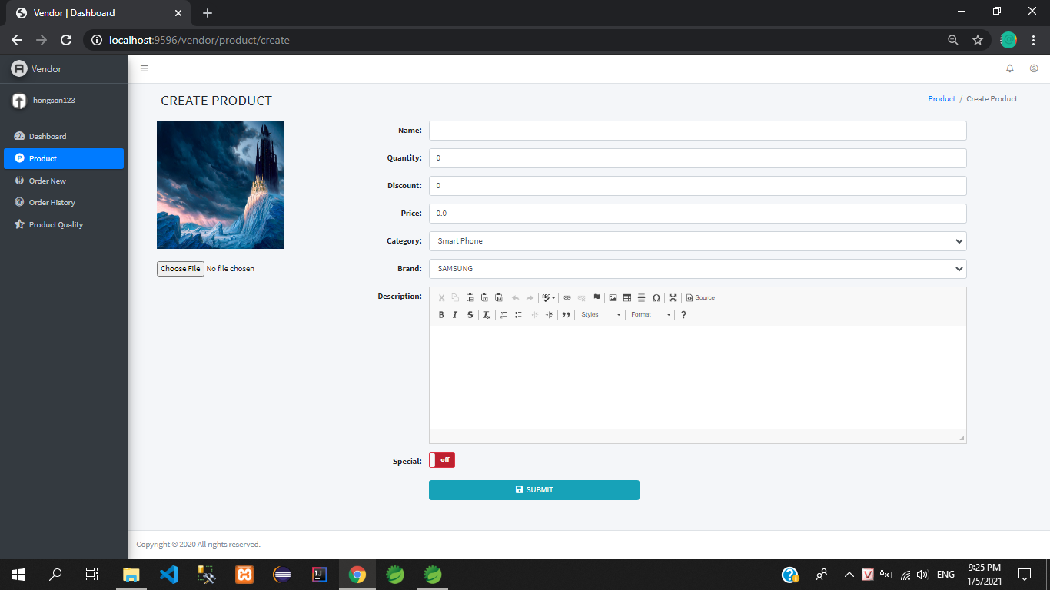

* Vendor manages its new orders

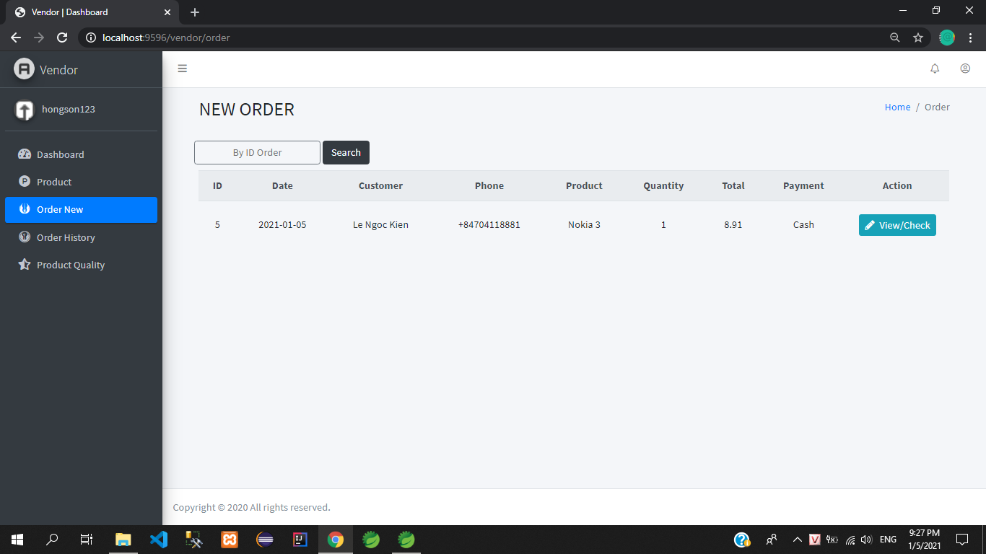

* Click the **View/Check** button to check and confirm orders and confirm delivery

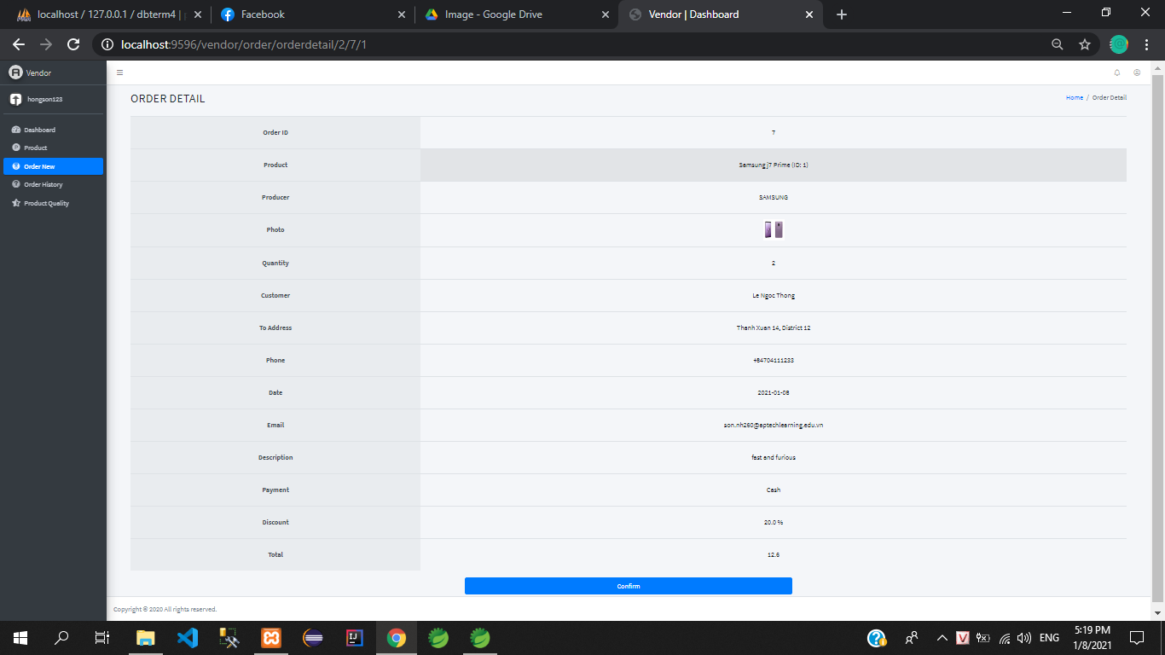

* Vendor can manage and review its old orders (Click the View/Check button to review old order details)

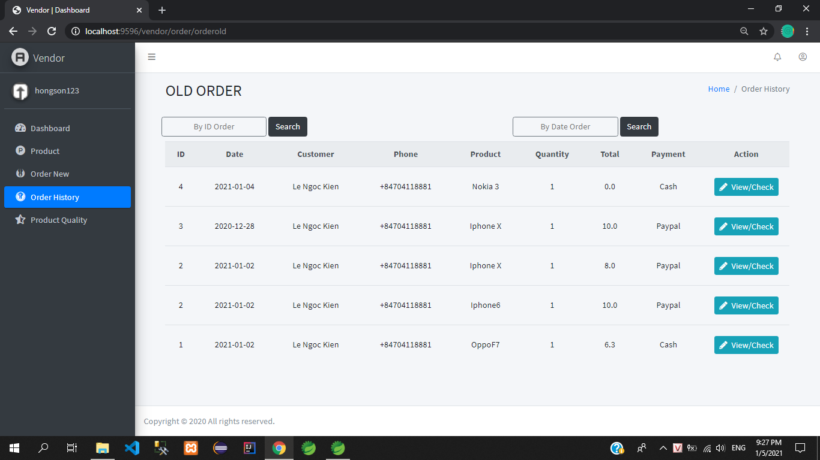

* Vendor can view the quality of its products and the rating of each product (customer reviews)

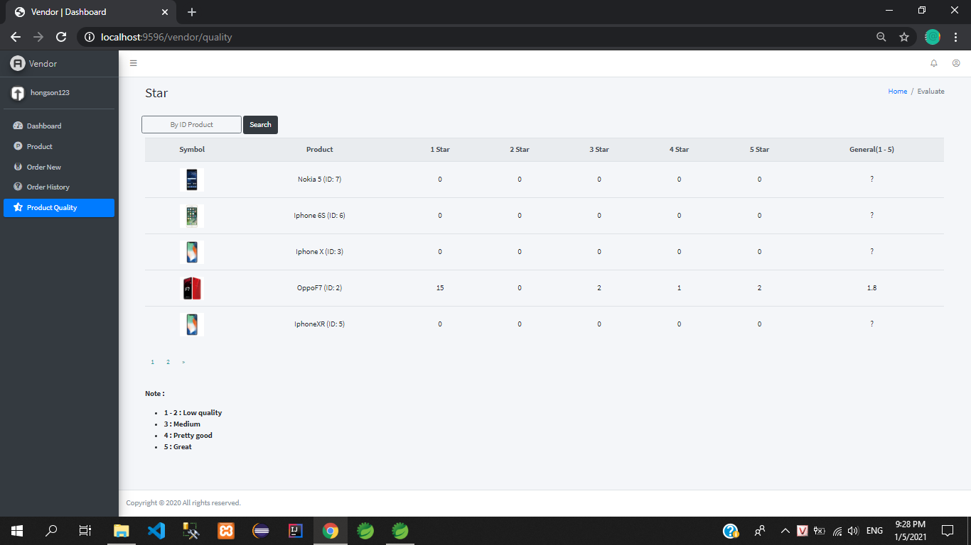

* Vendor can change passwords, change personal information and logout

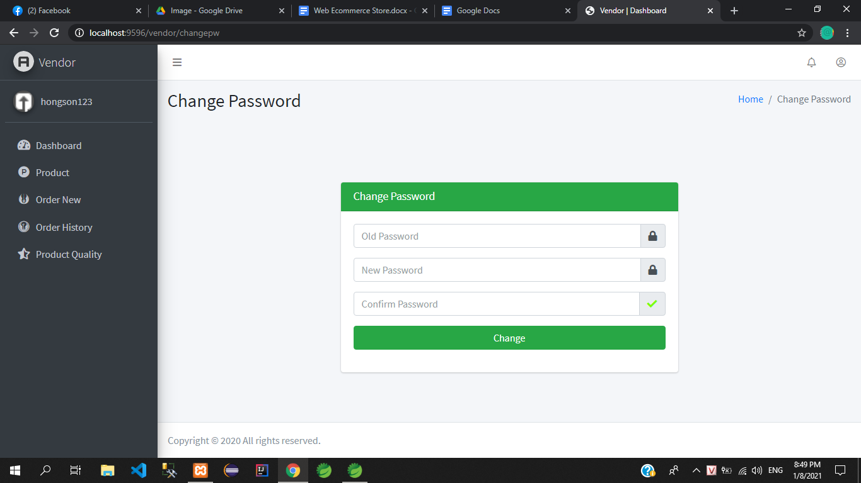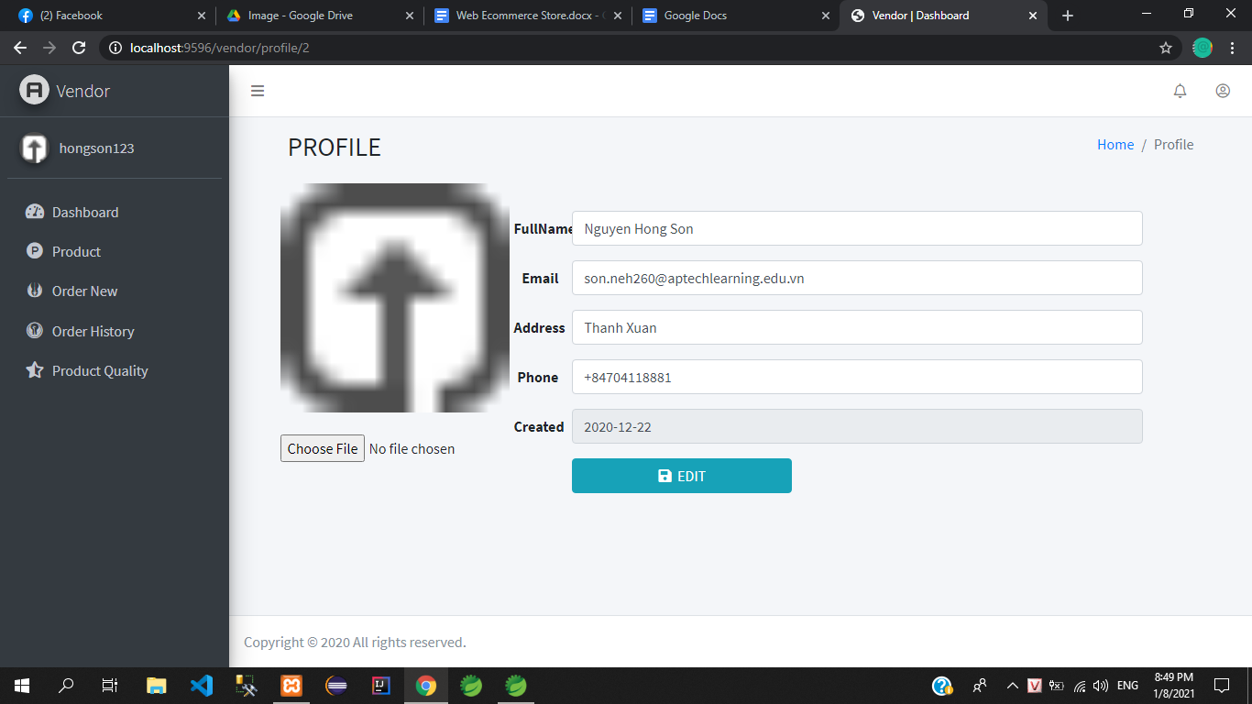

* Admin:
* Admin will manage the tables such as: statistics in the month, Category, Brand, Account …
* In the category table, we can add, delete, edit Category or Brand



* Admin can block customer and vendor accounts if they violate the website's rules



* Admin manages products created by vendor if it finds that inappropriate products can be removed



* Admin manages order history



* Admin can view the vendor's product review table. And can send an email to Vendor of the product rated 1 star multiple



* Finally , when the manager finishes his/her work , they can log their account out by Clicking the Log Out button below , and that is the end of the Admin side.

-----------------------------------------------------------------------------



* And finally , picture above show the construction of the database.

Database and Admin side wrote by Nguyen Hong Son.

* This is the end.

Thank you for spending your time on reading our project.



|  |  |  |
| --- | --- | --- |
|  |  |  |

*Nguyen Phuong Minh Thong ,*

*Ngo Hoang Phuc*

*and Nguyen Hong Son*

*wrote this project.*

*Approved By(Trainer): Mr.Phan Huu Tri.*